

|  |  |  |  |  |  |  |
| --- | --- | --- | --- | --- | --- | --- |
|  | | | | | | |
|  | | "Memory Arm" | | |  | |
|  |  | | | | |  |
|  | | |  |  | | |
|  | | | **Shani Inbar (ID: 301394227)**  **&**  **Liran Nachman (ID: 311342836)** 02/10/2021—Systems' Models & Simulation—Dr. Moshe Ayal |  | | |

**Table of Contents**

|  |  |  |
| --- | --- | --- |
| **Chapter** | | **Pages** |
| **1** | **Introduction** | **3-7** |
| **2** | **Project Description** | **8-17** |
| **3** | **Simulink Model and Simulation** | **18-31** |
| **4** | **Sensitivity Analysis** | **31-39** |
|  | **Appendix A: MediaPipe Pose** | **40-41** |
|  | **Appendix B: Sensitivity Analysis Raw Data** | **42-50** |
| **5** | **References** | **51-52** |

1. **Introduction**

The 21st century is rightly called "the machine age" as we are living in the world of machines. With the progress of technology, our daily routine became more and more dependent on machines, as they become an integral part it, everywhere and all the time.

Machines are the result of man’s effort to produce more work with less energy.

One of the main objectives of robotics engineering is to provide the ability for progress in various fields, which depends on the use of new and more efficient robotic assistants that produce better and wider solutions.

Robotics is being constantly and extensively conflated into multiple lines of work superseding human labor thus performing persistent and durable tasks.

Robotics is distinguished based on its types of application such as (i) Industrial (ii) Domestic or Household (iii) Medical (iv) Service (v) Military and (vi) Space.

Robotic manipulators and robotic arms were the very first robots to be used in industry, pioneers in third industrial revolution in the late 1960s [1].

The first designed of the robotic arm was for manufacturing and production processes; it has long been used for other purposes by researchers.

A large number of studies have focused on robots for helping individuals with physical challenges, for example, the desktop robotic system by Hammel [2].

With the continued progress in computing power, computer vision, and advanced sensors, research have started to focus on uses of robotic arms in daily life and work environments in project such as Care-O-bot [3] and the recent mobile manipulator robot, Personal Robot 2 (PR2) from Willow Garage [4].

Figures 1.1-1.3 presents the following systems.

**Figure no. 1.2: Care-O-bot** Hans et al., 2002

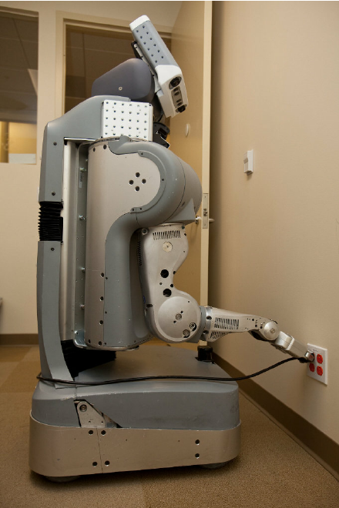

**Figure no. 1.3: The Willow Garage PR2 (Personal Robot 2),** Rusu et al., 2009

A comprehensive perception system with applications to mobile manipulation and grasping for personal robotics. Our approach makes use of dense 3D point cloud data acquired using stereo vision cameras by projecting textured light onto the scene.

The robotic arms can become a part of our daily living and working circumstances. The task and places users could use robotic arm to perform for them are diversified; figure no. 2 presents various examples.

**Figure no. 2: Robotic Arm potential uses**

Environment models serve as important resources for autonomous robots by providing them with the necessary task-relevant information about their habitats.

Based on the following assumption our suggested system "Memory Arm" provide a precise activity of a human arm, which could be adopted among various fields.

1. **Project Description**

The human arm consist a total of 7 Degree-of-Freedom [5]. DOF refers to the capacity of an object to move up and down, left and right and rotate.

The up-and-down movement is called the Pitch whereas the left-and-right movement is called the Yaw. The arm’s rotating ability is termed as the Roll.

Since the robot resembles the human arm, it has a base, which enables it to rotate 180 degrees connecting it to the manipulator above the base to represent that of a "shoulder" joint. Moreover, it has also rotational axes about its "elbow" and "wrist" joints [6].

Light Weight Robotic (LWR) arms can be defined as robots with minimum own weight, particularly dedicated to tasks in location where its adaptability is necessary in relation to certain operation in an unstructured environment [7]. In order to achieve this, they are required to be light and the payload has to be equivalent/ simultaneous to its own weight. Human arm’s motion differs from the motion of robotic arms [8]. Although the robot joints have lesser degrees of freedom compared to a human arm, they are able to move with larger angle.

The 'Memory Arm" project presents an anthropomorphic robot arm model design and simulation of 5 DOF jointed-arm robot.

The design’s aim is to mimic tasks performed by the human arm such as pick-and-place actions via machine learning.

* 1. **Mechanical design**
     1. The robot needs to be designed to mimic the movement of human arm. Therefore, this robot consists of robot base, shoulder, elbow, robot wrist and the end-effectors, which will be the robot’s gripper.

Since this project involved the fabrication of human operation capabilities, there are several design requirements to be taken in consideration.

Following are the robotic arm specifications:

A) Revolute Jointed-Arm

B) Degree of freedom (DOF): **5** DOF

C) Maximum range of motion per joint: **≤180º**

D) 5 servomotors: **one for the base, one each for the shoulder, elbow, wrist and the gripper.**

E) Payload capacity: **500g**

F) Constructive Material: **Acrylonitrile Butadiene Styrene (ABS) plastic**

Among the fundamental design parameters of a robotic arm, the ratio between the structure weight and the strength that can be hold by it are especially relevant [9], and both of them are intrinsically related to the usual building materials, namely, aluminum and steel. Our aim is to improve these two key parameters by using ABS plastic in the design and construction of a robotic arm structure with five degrees of freedom. ABS plastic is a relatively light material and the most suitable one for robotic arms prototypes [10]. This material has robust features of resistance and hardness, and more, it is significantly lower-cost than aluminum or steel.

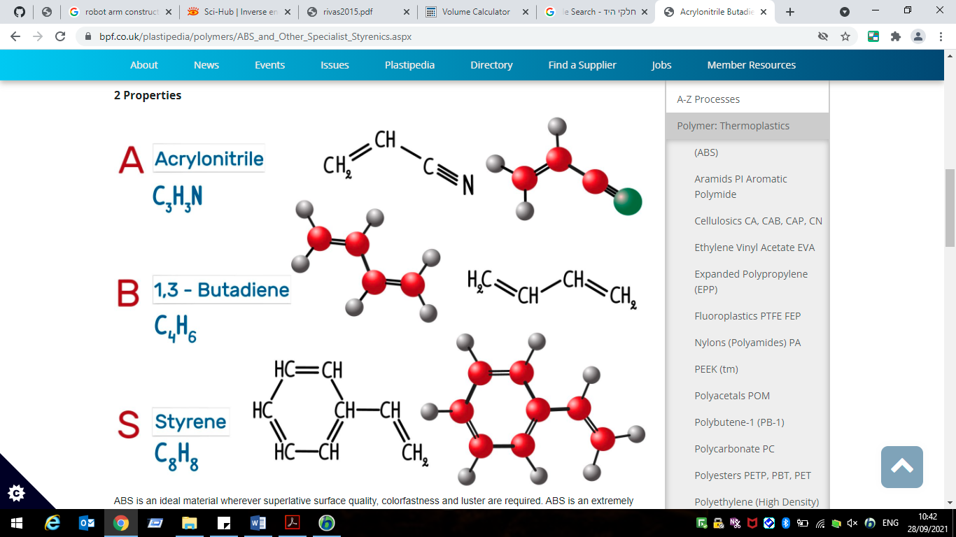

**Figure no. 3: Acrylonitrile, Butadiene, Styrene chemical structure**

* + 1. **Determination of Torque Requirement of Joints:**

After the structure of the robot arm is determined, motion for each joint needs to be developed.

To effect motion of the links of a robotic arm, an actuator is fixed at each joint of the arm. The actuator applies torque at the joint to overcome the resistance of the link to motion. Resistance of any link to motion is due to gravity and inertia effects. The joints of the manipulator experience different amount of torques depending on their locations in the structure of the manipulator.

The effect of gravity on any link of the robot is to pull and accelerate it towards the center of the earth due to its own weight, thus exerting a resistive torque on it. Therefore, a portion of the torque generated by the actuator is needed to overcome this resistive torque (due to gravity). It was necessary to calculate the value of the gravity-induced resistive torque acting on each link of the arm, so that an actuator with sufficient torque rating could be selected for each joint.

Therefore, torque calculation was carried out for selecting the servomotors that drive the individual joints of the robot arm.

The resistive torque exerted on a joint due to gravity acting on the robot depends very strongly on the robot’s pose. Intuitively the torque on the shoulder joint is much greater when the arm is stretched out horizontally. So, in order to calculate the torque required at each joint, the worst case scenario (arm completely stretched out) was chosen. The arm is subjected to the highest torque when the arm is stretched horizontally [11].

Torque is defined as twisting force. It is calculated using the following equation:

|  |  |
| --- | --- |
| **Moment** |  |
| **Consider** | |
| **Mass to be lifted** | 500g/0.5Kg |
| **Density of the solid to be used (d):** | 1-1.05g/cm3 (⁓1 g/cm3) |

The following tables describes the links' dimensions, volume, mass, and joints' mass.

|  |  |
| --- | --- |
| **Dimensions estimation:** | |
| **Base** | Length :15cm Radius: 5cm |
| **Shoulder link** | Length: 4cm  Width: 3cm  Height: 10cm |
| **Upper-arm link** | Length: 2cm  Width: 2cm  Height: 10cm |
| **Forearm link** | Length: 2cm  Width: 1.5cm  Height: 10cm |
| **Wrist link** | Length: 10cm  Radius: 1cm |
| **Gripper** | Length: 1cm  Width: 1cm  Height: 5cm |

***Table no. 1.1 Links dimensions***

|  |  |
| --- | --- |
| **Volume estimation**: | |
| **Volume of Base** (πr2h) | 1178.098 cm3 |
| **Volume of Shoulder** (L\*W\*H) | 120 cm3 |
| **Volume of upper-arm** (L\*W\*H) | 40 cm3 |
| **Volume of forearm links** (L\*W\*H) | 30 cm3 |
| **Volume of wrist** (πr2h) | 31.416 cm3 |
| **Volume of gripper** (L\*W\*H) | 5 cm3 |

***Table no. 1.2 Links volumes***

|  |  |
| --- | --- |
| **Mass estimation**: | |
| **Mass of Base** (M=d\*V) | 1178.098g=1.178Kg |
| **Mass of Shoulder** (M=d\*V) | 120g=0.12Kg |
| **Mass of upper-arm** (M=d\*V) | 40g=0.04Kg |
| **Mass of forearm links** (M=d\*V) | 30g=0.03Kg |
| **Mass of wrist** (M=d\*V) | 31.416g=0.031Kg |
| **Mass of gripper** (M=d\*V) | 5g=0.005Kg |
|  | |
| **Base- Shoulder Joint 1** | 65g=0.065Kg |
| **Shoulder- upper-arm Joint 2** | 65g=0.065Kg |
| **Upper-arm- forearm Joint 3** | 65g=0.065Kg |
| **Forearm- wrist Joint 4** | 65g=0.065Kg |
| **Wrist- gripper Joint 5** | 36g=0.036Kg |

***Table no. 1.3 Links & Joints mass***

Torques estimations of joints 1-5 in a stretched-out arm are calculates as follows; Figure no.4 presents free-body diagram (FBD) of the stretched-out arm with the direction of forces the motor's motion.

|  |  |
| --- | --- |
| **Torques (moments) estimations**: | **Force × distance (Kg-cm)** |
| **Base- Shoulder Joint 1 (**T1g) | The waist rotation does not cause motion of any link in the vertical**.** |
| **Shoulder- upper-arm Joint 2 (**T2g) | **T2g=W2\*(L2/2)+ WJ3\*L2+W3\*(L2+L3/2)+**  **(WJ4+W4+WJ5+WGripper+Wpayload)(L2+L3)**  **T2g=**(0.04Kg\*(10cm/2))+(0.065Kg\*10cm)+ (0.03Kg\*(10cm+(10cm/2)))+((0.065Kg+0.031Kg +0.036Kg+0.005Kg+0.5Kg)\*(10cm+10cm)**)**  **T2g=0.2+0.65+0.45+12.74=14.04 Kg-cm** |

|  |  |
| --- | --- |
| **Torques (moments) estimations**: | **Force × distance (Kg-cm)** |
| **Upper-arm- forearm Joint 3**  **(**T3g) | **T3g=W3\*(L3/2)+(WJ4+W4+WJ5+WGripper+Wpayload)(L3)**  **T3g=**(0.03Kg\*(10cm/2))+((0.065Kg+0.031Kg +0.036Kg+0.005Kg+0.5Kg)\*10cm)  **T3g=0.15+6.37=6.52 Kg-cm** |
| **Forearm- wrist Joint 4 (**T4g) | **T4g=L4\*( WJ5+WGripper+Wpayload)+(L4/2)\*W4**  **T4g=**(10cm\*(0.036Kg+0.005Kg+0.5Kg))+((10cm/2)\* 0.031Kg)  **T4g=5.41+0.155=5.565 Kg-cm** |
| **Wrist- gripper Joint 5 (**T5g) | The Gripper does not result in motion against gravity. |

***Table no. 1.4 Torques estimations***

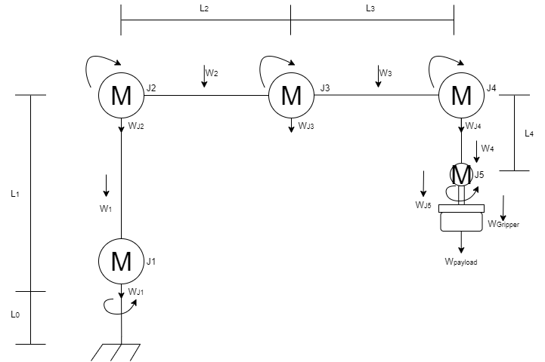

**Figure no. 4: Free-body-diagram of robot arm in stretched out pose**

**Legend:**

|  |  |  |
| --- | --- | --- |
| W1 - Weight of link L1 (Shoulder) | WJ1 - Weight of joint 1 | T1g - Resistive torque at joint 1 due to gravity |
| W2 - Weight of link L2  (Upper-arm) | WJ2 - Weight of joint 2 | T2g - Resistive torque at joint 2 due to gravity |
| W3 - Weight of link L3  (Forearm) | WJ3 - Weight of joint 3 | T3g - Resistive torque at joint 3 due to gravity |
| W4 - Weight of link L4  (Wrist) | WJ4 - Weight of joint 4 | T4g - Resistive torque at joint 4 due to gravity |
| WGripper - Weight of Gripper | WJ5 - Weight of joint 5 | T5g - Resistive torque at joint 5 (Gripper joint) due to gravity |
| Wpayload - Weight of payload |  |  |

The resistance that is shown by a body to change its rotation is called moment of inertia (*I*). Thus, the difficulty faced to change the angular motion of a body about an axis is measured by calculating its moment of inertia about that particular axis. The moment of inertia plays the same role for rotation as the mass does for a translational motion. It describes the angular acceleration produced by an applied torque [12]. It follows that, for a given angular acceleration of any link of the robot, the inertia of the link results in a resistive torque applied at the joint where the lower end of the link is connected. The value of this torque (Ti) is given by the product of the moment of inertia of the link and it's angular acceleration, α [12].

Ti = *I*α

According to Benenson et al. (2006) [13], the moment of inertia of a body depends on its shape and mass distribution as well as the orientation of its rotational axis, so it is necessary to use a different formula to calculate the moment of inertia for each link of the robotic arm:

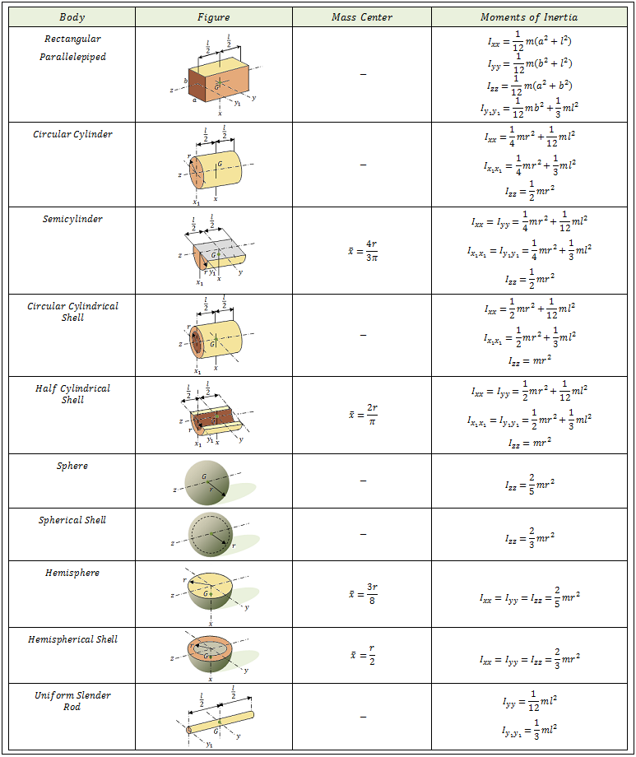

The calculation can be made using Simulink.

* 1. **Control system**

A part from mechanical design, electrical system used also to be taken into consideration. Electricity is the most common source of power and is used extensively with industrial robots. Following are the component used in this project.

* + 1. **Microcontroller**

**Arduino Uno** is a microcontroller board based on the ATmega328P. It is an open-source platform, which is designed for prototyping projects.

Arduino has 14 digital input/output pins (of which 6 can be used as PWM outputs), 6 analog inputs, a 16 MHz ceramic resonator (CSTCE16M0V53-R0), a USB connection, a power jack, an ICSP header and a reset button.

It will be used to control all the five servomotors of the robot arm.

* + 1. **Power Supply:**

The operating voltage of the Arduino board is +5V. This can be easily supplied by using the USB cable connected to the computer. Each individual servomotor also requires voltage supply of +5v. Arduino has a built in voltage regulator which supplies 5V but this single voltage output is not enough to power all five servomotors. Therefore, an alternate power source, which is the CPU Power Supply Unit is used. The signal is being sent by the Arduino board to the servomotor to position the arm. Pin 3, 5, 6, 9, 10 in the Arduino board will be used for base, shoulder, elbow, wrist and gripper respectively.

Figure no. 5 shows the project equivalent circuit.

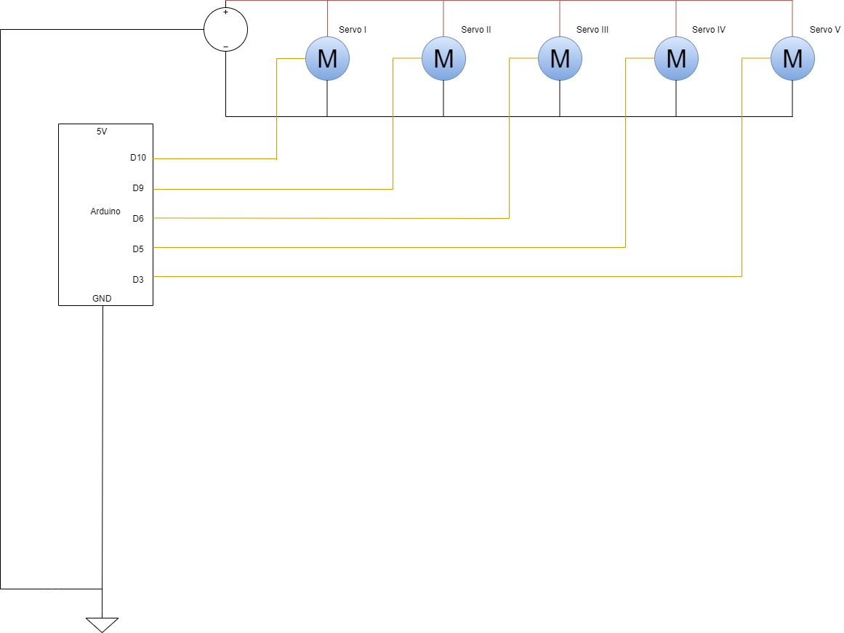

**Figure no. 5: Memory Arm equivalent circuit**

1. **Simulink Model and Simulation**
   1. Simscape Multibody used for modeling in this project, provides a multibody simulation environment for 3D mechanical systems, such as robotic arm.

The model created for this project uses mainly three blocks:

**Solid:** Represents a solid combining a geometry, an inertia and mass, a graphics component, and rigidly attached frames into a single unit. A solid is the common building block of rigid bodies.

**Revolute Joints:** This block Represents a revolute joint acting between two frames and has one rotational degree of freedom.

**Rigid transform:** Defines a fixed 3-D rigid transformation between two frames.

The manipulator under consideration has five revolute joints, which are modeled using the revolute joint block described. Manipulator links are represented by solid blocks, a total of seven solid block is used for our model. Position and orientation of solid blocks and joints are assigned using rigid transformation, which gives us option to translate and rotate the blocks.

Figures no. 6-11 shows the solids components that compose the robotic arm.

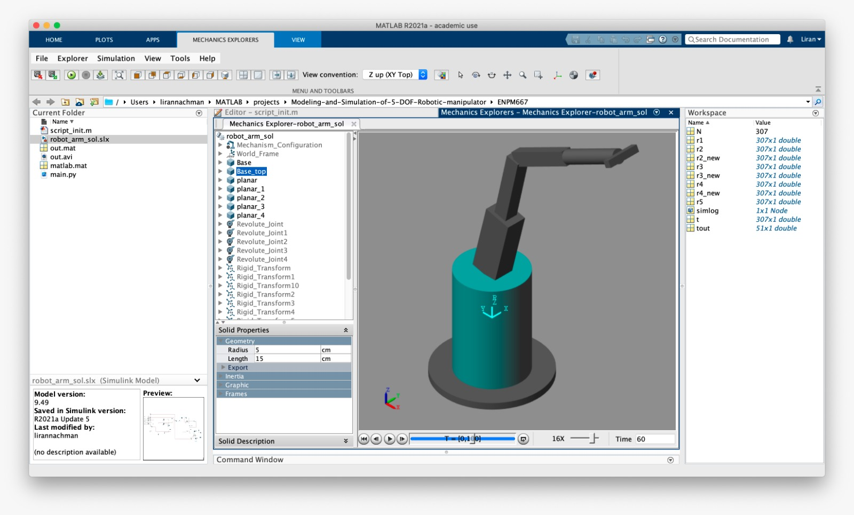

**Figure no. 6: Base component**

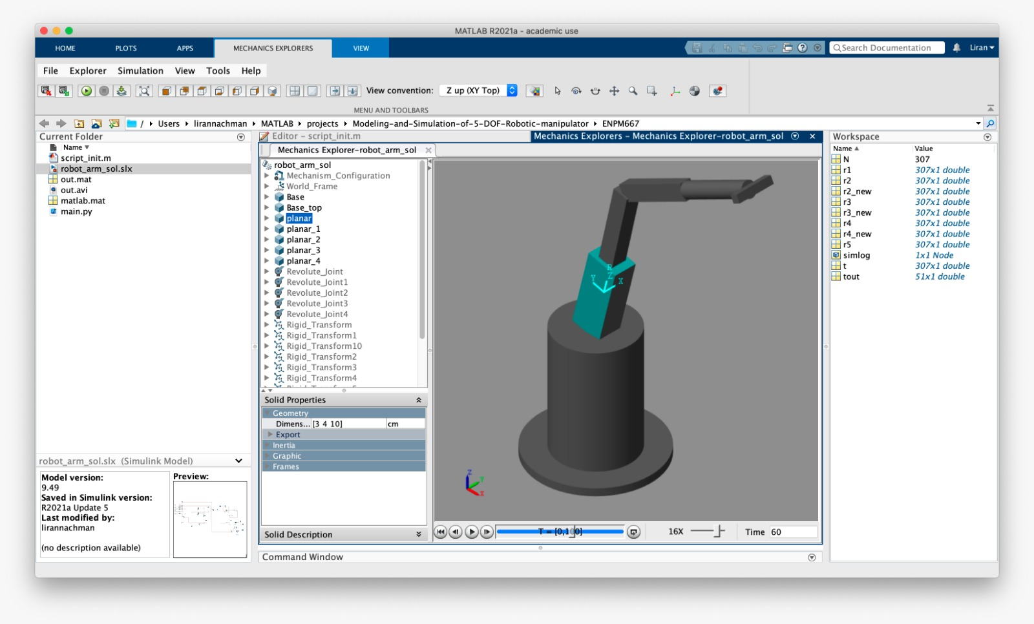

**Figure no. 7: Shoulder component**

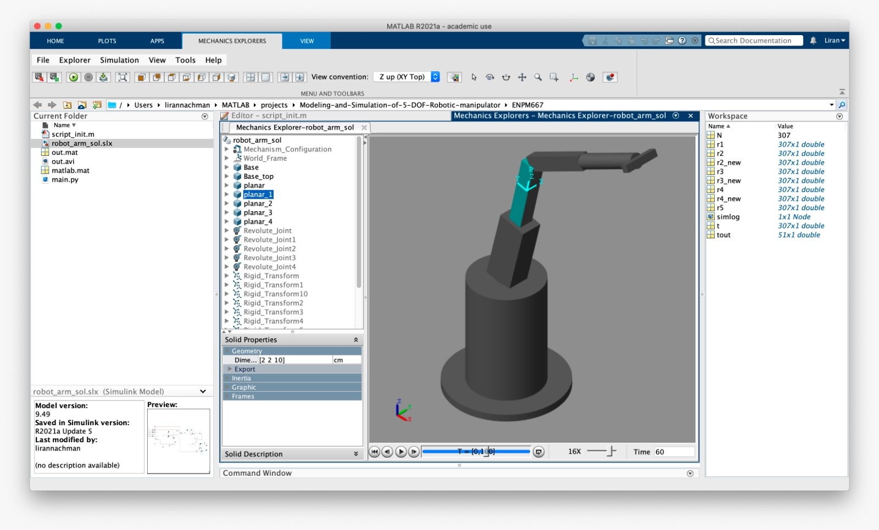**Figure no. 8: Upper arm component**

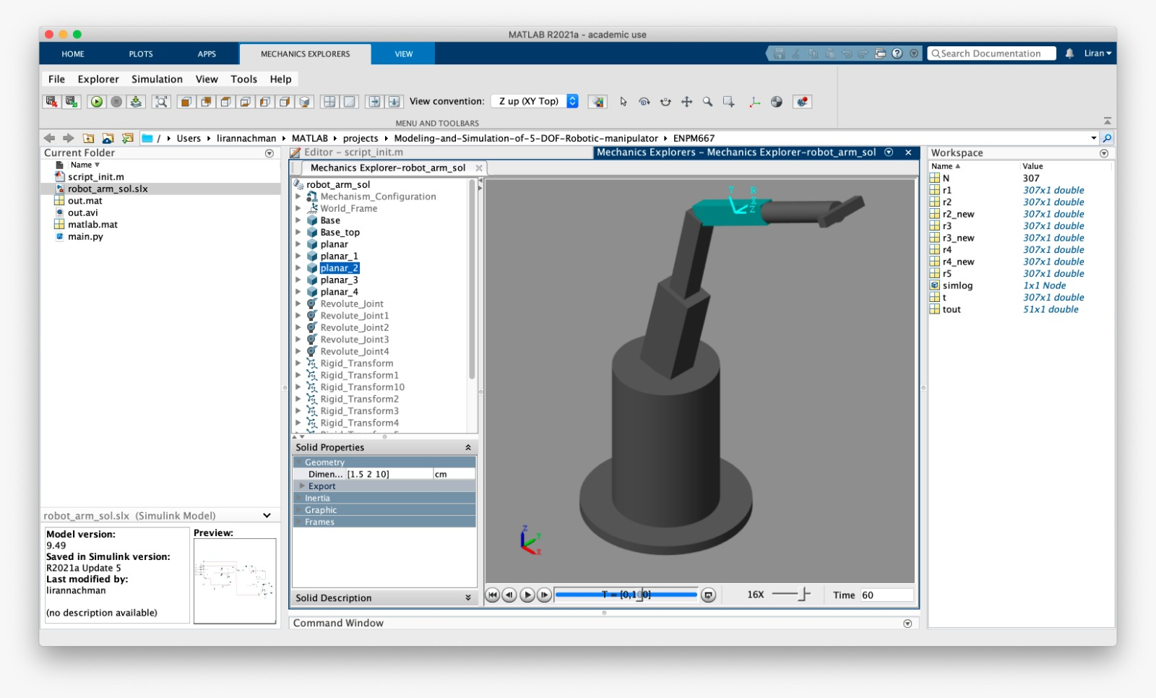  
**Figure no. 9: Forearm component**

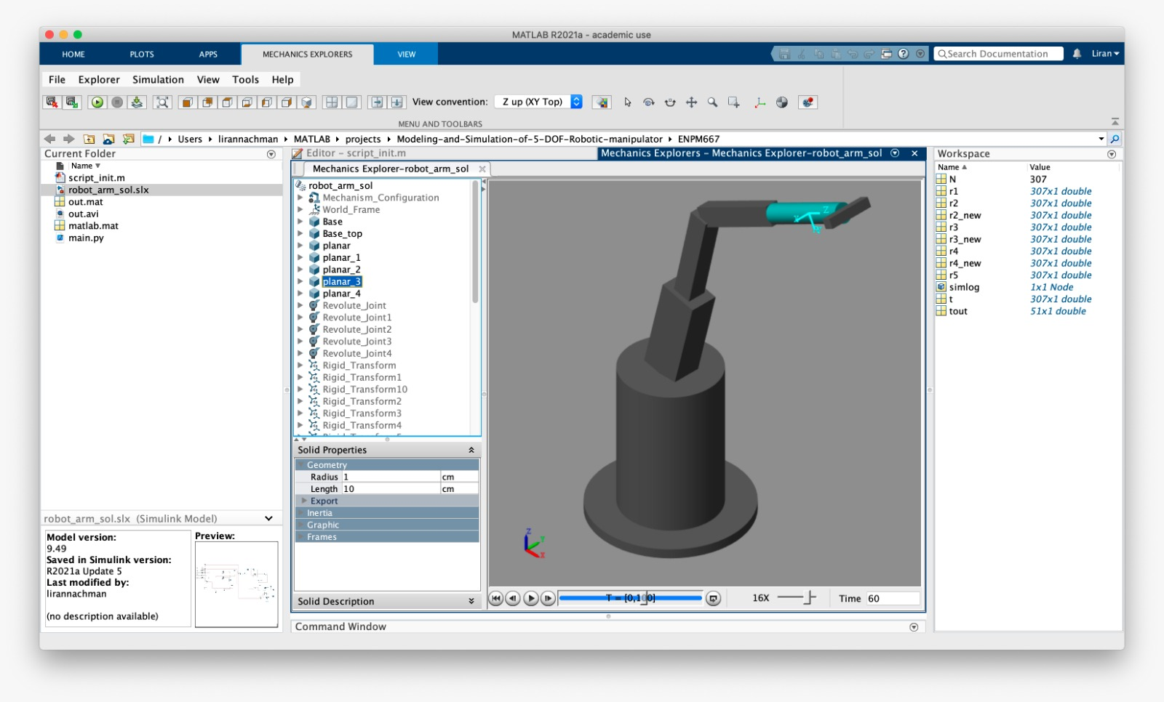

**Figure no. 10: Wrist component**

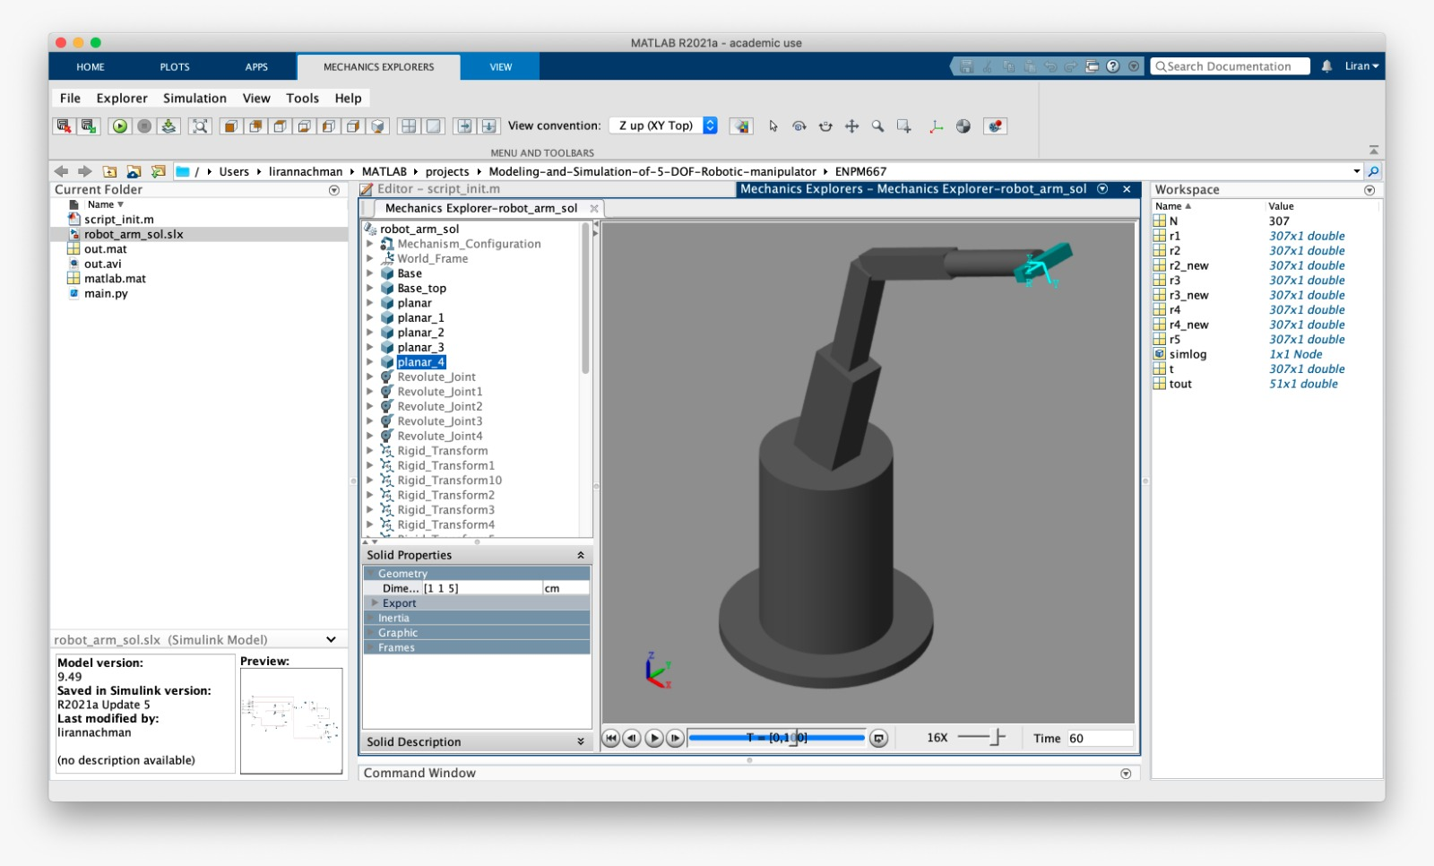  
**Figure no. 11: Gripper**

* 1. **Simulink Diagram**

Figure no. 12 presents the Simulink diagram of the "Memory Arm" model.

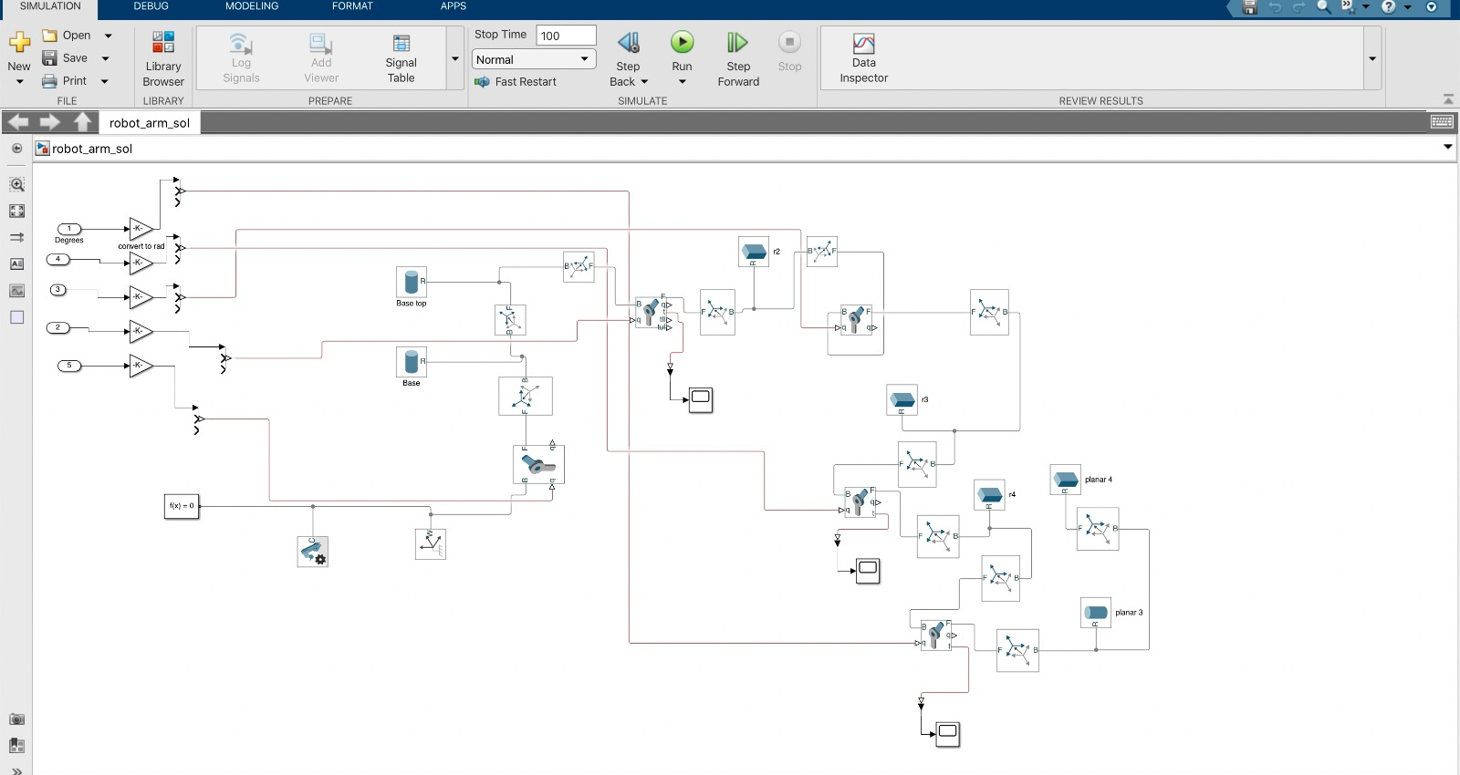

**Figure no. 12 Simulink Diagram**

* 1. **Model's Python Code**

In order to use our robotic arm model as a "Memory Arm" we needed to enable it to track human arm movements and accurately mimic it.

The following characteristic will enable the "Memory Arm" to be used in various tasks according to the user requirements.

Human posture and Range of Motion is a vital component to provide a natural way for interaction and communication in "Augmented reality" (AR) and "Virtual Reality" (VR), and has been an active research topic in the industry [14]. Vision-based pose estimation has been studied for many years. A large portion of previous work requires specialized hardware, e.g. depth sensors [15]. Other solutions are not lightweight enough to run real-time on commodity mobile devices [16] and thus are limited to platforms equipped with powerful processors.

In this project, we propose a solution that does not require any additional hardware and perform human arm movement according to a pre-recorded camera video.

Our main contributions is an efficient two-stage tracking pipeline that can track multiple human arm movements by a pose estimation model that is capable of predicting 3D arm pose.

The following Python code was used (explanations of each step describe in green):

|  |
| --- |
| **"""Step 1 Explanation:** CV2 is a library of Python bindings designed to solve computer vision problems."""    import cv2  **"""Step 2 Explanation:** We have used MediaPipe Pose (pre-trained Neurons Network (NN)), which is a ML solution for high-fidelity body pose tracking, inferring 33 3D landmarks and background segmentation mask on the whole body from RGB video frames.  The solution utilizes a two-step detector-tracker ML pipeline.  Using a detector, the pipeline first locates the person/pose region-of-interest (ROI) within the frame. The tracker subsequently predicts the pose landmarks and segmentation mask within the ROI using the ROI-cropped frame as input. See Appendix A"""  import mediapipe as mp import numpy as np import math from scipy import io import time  """**Step 4 Explanation:** The angle function between two points provides the angle degree between them (by the calculating the tangent). An edge case was defined: if the angle between two points is negative, it will be defined as 180º (it is a limitation of the servomotor, Required Range: 0º-180º)."""  def angleBetweenPoints(a, b):  deltaY = b["y"] - a["y"]  deltaX = b["x"] - a["x"]  degree = math.atan2(deltaX, deltaY) \* 180 / math.pi  if degree < 0:  return 180  return degree  """**Step 5 Explanation:** The main function for the simulation."""  def simulation():  """**Step 6 Explanation:** In order to allow the preparation of the camera, we have defined nine seconds delay from the function initiation."""     time.sleep(9)  print("Starting...")  """**Step 7 Explanation:** We have set empty arrays for r2,r3,r4 which will save the angles degree in relation to time."""  r2 = []  r3 = []  r4 = []  """**Step 8 Explanation:** constants definition: limit the max number of video frames video for a short video, font scale, color and thickness"""  MAX\_FRAMES = 250  mp\_pose = mp.solutions.pose  font = cv2.FONT\_HERSHEY\_SIMPLEX  # fontScale  fontScale = 1  # Blue color in BGR  color = (0, 255, 0)  # Line thickness of 2 px  thickness = 2  line\_thickness = 2  """**Step 9 Explanation:** Starting the video from the webcam."""  cap = cv2.VideoCapture(0)  frame\_width = int(cap.get(3))  frame\_height = int(cap.get(4))  """**Step 10 Explanation:** The video recorded is further debugged (process of detecting and removing of existing and potential errors) and analyzed."""  out = cv2.VideoWriter('out.avi', cv2.VideoWriter\_fourcc('M', 'J', 'P', 'G'), 10, (frame\_width, frame\_height))  """**Step 11 Explanation:** Instruction for using the model."""  with mp\_pose.Pose(  min\_detection\_confidence=0.5,  min\_tracking\_confidence=0.5) as pose:  """**Step 12 Explanation:** Instruction for camera operation (on state) until MAX\_FRAMES is positive"""  while cap.isOpened() and MAX\_FRAMES >= 0:  success, image = cap.read()  if not success:  print("Ignoring empty camera frame.")  # If loading a video, use 'break' instead of 'continue'.  break   MAX\_FRAMES -= 1  """**Step 13 Explanation:** Instruction for image formatting to RGB, for the model's operation."""  # Flip the image horizontally for a later selfie-view display, and convert  # the BGR image to RGB.  image = cv2.cvtColor(cv2.flip(image, 1), cv2.COLOR\_BGR2RGB)  # To improve performance, optionally mark the image as not writeable to  # pass by reference.  image.flags.writeable = False  """**Step 14 Explanation:** Instruction for predict the pose according to the image and get results."""  results = pose.process(image)   height, width, deep = image.shape   if results.pose\_landmarks is None:  continue  """**Step 15 Explanation:** Instruction for taking the relative points from the model."""  leftArm = {"x": int(results.pose\_landmarks.landmark[11].x \* width),  "y": int(results.pose\_landmarks.landmark[11].y \* height)}  leftElbow = {"x": int(results.pose\_landmarks.landmark[13].x \* width),  "y": int(results.pose\_landmarks.landmark[13].y \* height)}  leftHand = {"x": int(results.pose\_landmarks.landmark[15].x \* width),  "y": int(results.pose\_landmarks.landmark[15].y \* height)}  leftHandler = {"x": int(results.pose\_landmarks.landmark[19].x \* width),  "y": int(results.pose\_landmarks.landmark[19].y \* height)}    """**Step 16 Explanation:** Instruction for calculating the angle between the arm and elbow.  Note: The results will be append to r2,r3,r4 array (see step 7 in the mentioned above), we have subtract 180 degrees from the result because in the simulink robotic arm model the Z axis is defined on Top while in the video, the Y axis is defined on top, therefore, we have shifted the axis by 180 degrees."""  init\_angle = angleBetweenPoints(leftArm, leftElbow)  middle\_angle = angleBetweenPoints(leftElbow, leftHand)  high\_angle = angleBetweenPoints(leftHand, leftHandler)    """**Step 17 Explanation:** Instruction for drawing circles on the images, the points of the arm, elbow and hand."""  image = cv2.circle(image, (leftArm["x"], leftArm["y"]), 10, (50, 0, 0), thickness)  image = cv2.circle(image, (leftElbow["x"], leftElbow["y"]), 10, (100, 0, 0), thickness)  image = cv2.circle(image, (leftHand["x"], leftHand["y"]), 10, (200, 0, 0), thickness)  image = cv2.circle(image, (leftHandler["x"], leftHandler["y"]), 10, (250, 0, 0), thickness)   # Draw the pose annotation on the image.  image.flags.writeable = True  image = cv2.cvtColor(image, cv2.COLOR\_RGB2BGR)  """**Step 18 Explanation:** Instruction for drawing lines between the points."""  cv2.line(image, (leftArm["x"], leftArm["y"]), (leftElbow["x"], leftElbow["y"]), (0, 100, 0),  thickness=line\_thickness)  cv2.line(image, (leftElbow["x"], leftElbow["y"]), (leftHand["x"], leftHand["y"]), (0, 200, 0),  thickness=line\_thickness)  cv2.line(image, (leftHand["x"], leftHand["y"]), (leftHandler["x"], leftHandler["y"]), (0, 255, 0),  thickness=line\_thickness)  """**Step 19 Explanation:** Instruction for drawing text of the angles values together with X and Y positions."""  image = cv2.putText(image,  str(int(init\_angle)) + str(" x: " + str(leftArm["x"]) + ", y:" + str(leftArm["y"])),  (leftArm["x"], leftArm["y"]), font,  fontScale, color, thickness, cv2.LINE\_AA)   image = cv2.putText(image, str(int(middle\_angle)) + str(  " x: " + str(leftElbow["x"]) + ", y:" + str(leftElbow["y"])), (leftElbow["x"], leftElbow["y"]), font,  fontScale, color, thickness, cv2.LINE\_AA)   image = cv2.putText(image,  str(int(high\_angle)) + str(" x: " + str(leftHand["x"]) + ", y:" + str(leftHand["y"])),  (leftHand["x"], leftHand["y"]), font,  fontScale, color, thickness, cv2.LINE\_AA)  r2.append(180 - int(init\_angle))  r3.append(180 - int(middle\_angle))  r4.append(180 - int(high\_angle))  """**Step 20 Explanation:** Instruction for showing the image."""  cv2.imshow('MediaPipe Pose', image)  out.write(image)  if cv2.waitKey(5) & 0xFF == 27:  break  """**Step 21 Explanation:** Instruction for shutting down the video and recording."""  out.release()  cap.release()  """**Step 22 Explanation:** Instruction for returning the results obtained"""  return [r2, r3, r4]  """**Step 23 Explanation:** Instruction for operating the Main function, running the simulation, getting the results and save them on matlab Matrix which called out.mat."""  [r2, r3, r4] = simulation() r2 = np.array(r2) r3 = np.array(r3) r4 = np.array(r4) io.savemat('./out.mat', mdict={'r2': r2, 'r3': r3, 'r4': r4}) |

* 1. **Model's Matlab Code**

After composing the model code using Python, we was required to connect it to the model simulation formed in Simulink by using Matlab.

|  |
| --- |
| !python3 main.py   **Explanation:**  **The array is presented as follows: Each r1,r2,r3,r4,r5 presents an array of N elements (N frames),**  **Each element display the degrees of the robotic arm motors.**   % t: 0 1 2 3 4 5 6 N % r1: 0 12 30 50 60 70 80 % r2: 0 80 30 50 60 70 80     %load out.mat r1..N from python script   load("out.mat") N = length(r2);   t = transpose(0:1:N-1);     **Explanation: we have decided the motors 2,3 & 4 will be functional while 1 & 5 is paused.**  r1 = zeros(N,1) + 90; % 90 90 90 90 90 N % r1 rotate top r5 = zeros(N,1) + 0; % rotate base   r2 = transpose(double(r2));  r3 = transpose(double(r3)); r4 = transpose(double(r4));   **Explanation: we have used an additional function call "smooth" which will be further clarify in the next chapter, we will receive new values for r2, r3, r4.**  % smooth signals with Savitzky-Golay Filters  r2\_new = sgolayfilt(r2, 5, 21); r3\_new = sgolayfilt(r3, 5, 21); r4\_new = sgolayfilt(r4, 5, 21);   % figure % hold all;   % plot(t,[r2,r2\_new]);    % legend("Second arm (r2) degrees ", ... % "Order 5 - Smooth second arm (r2) degrees");   % title("Second Arm (r2) Degrees Servo By Time");   % xlabel("Frames"); % ylabel("Degrees 0~180");    % plot(t,[r3,r3\_new]); % legend("Elbow arm (r3) degrees ","Smooth Elbow arm (r3) degrees"); % title("Elbow Arm (r3) Degrees Servo By Time"); % xlabel("Frames"); % ylabel("Degrees 0~180");  % plot(t,[r4,r4\_new]);     % legend("Top arm (r4) degrees ","Smooth Top arm (r4) degrees"); % title("Top Arm (r4) Degrees Servo By Time"); % xlabel("Frames"); % ylabel("Degrees 0~180");   % settings new vars % csv\_export = [t r2 r2\_new]; % writematrix(csv\_export,'motions.csv')    r2 = r2\_new; r3 = r3\_new; r4 = r4\_new;   sim("robot\_arm\_sol",1:N) |



**Remarks:**

A. Double click on the demo in order to operate the video.

B. Please note a small delay is present between the video and the model.

1. **Sensitivity Analysis**

As describe in the previous chapters the "Memory Arm" model predicts the pose landmarks in the video presented and the robotic arm movement is operating in accordance to the angles and position analysis.

The operating tasks of the system are various, in order to allow a more precise and delict movements, which enable it to complete the tasks requested with higher rates, signal processing is needed.

Signal processing techniques can be used to improve transmission, storage efficiency and subjective quality and to also emphasize or detect components of interest in a measured signal.

Our model used "Smoothing" function as signal processing.

"Smoothing" is a method of reducing the noise within a data set. The data is smoothed by Savitzky-Golay filter.

In Savitzky and Golay approach [17], each successive subset of 2m+1 points is fitted by a polynomial of degree p (p≤2m) in the least-squares sense. The dth (0≤d≤p) differentiation (zeroth differentiation=smoothing) of the original data at the midpoint is obtained by performing the differentiation on the fitted polynomial rather than on the original data. Finally, the running least-squares polynomial fitting can be simply and automatically performed by convolving the entire input data with a digital filter of length 2m+1: The convolution coefficients can be obtained for all data points, all polynomial degrees and all differentiation orders but with only an odd number of data sets [18].

The five servomotors used in the robotic arm model are represented by r1, r2, r3, r5, r6 in figure no. 13.

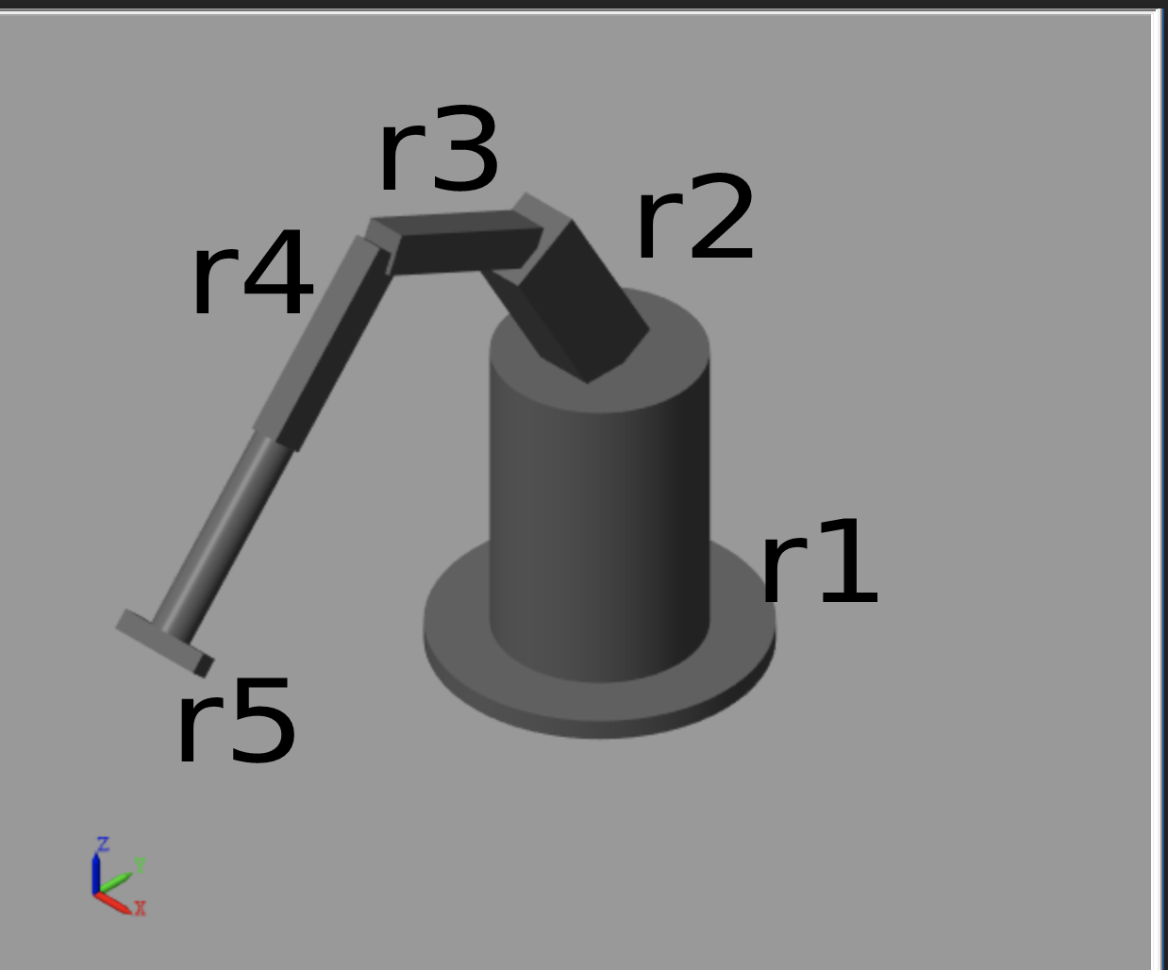

**Figure no. 13: Robot arm model with servomotor representation**

Our model uses the operation of three servomotors r2, r3, r4; in order to estimate the signal processing using the "Smooth" function, on the operation of the servomotors, we have analyzed r2 (servomotor no. 2) before and after the function implementation.



**Remark:** Double click on the demo in order to operate the video.

Figure no. 14 presents a graph of the degrees values by time frames of servomotor no. 2 before signal processing.

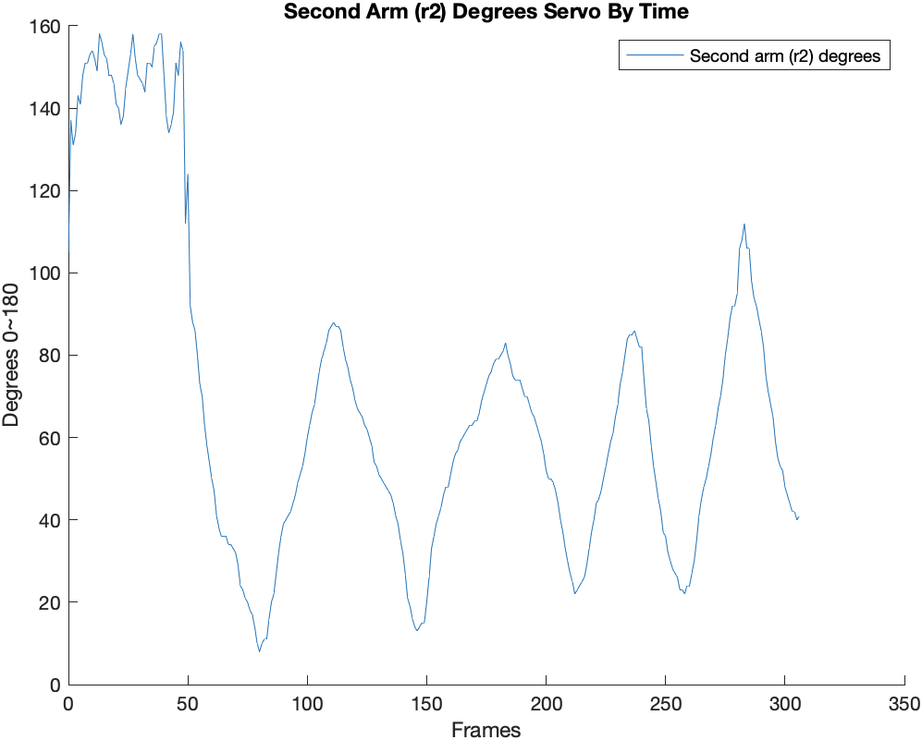

**Figure no. 14: Servomotor r2 operation, degrees vs. time frames.**

Figure no. 15 presents the Servomotor r2 operation after implementation of sgolay (order,framelen) function which designs a Savitzky-Golay FIR smoothing filter with polynomial (order)order and frame length framelen.

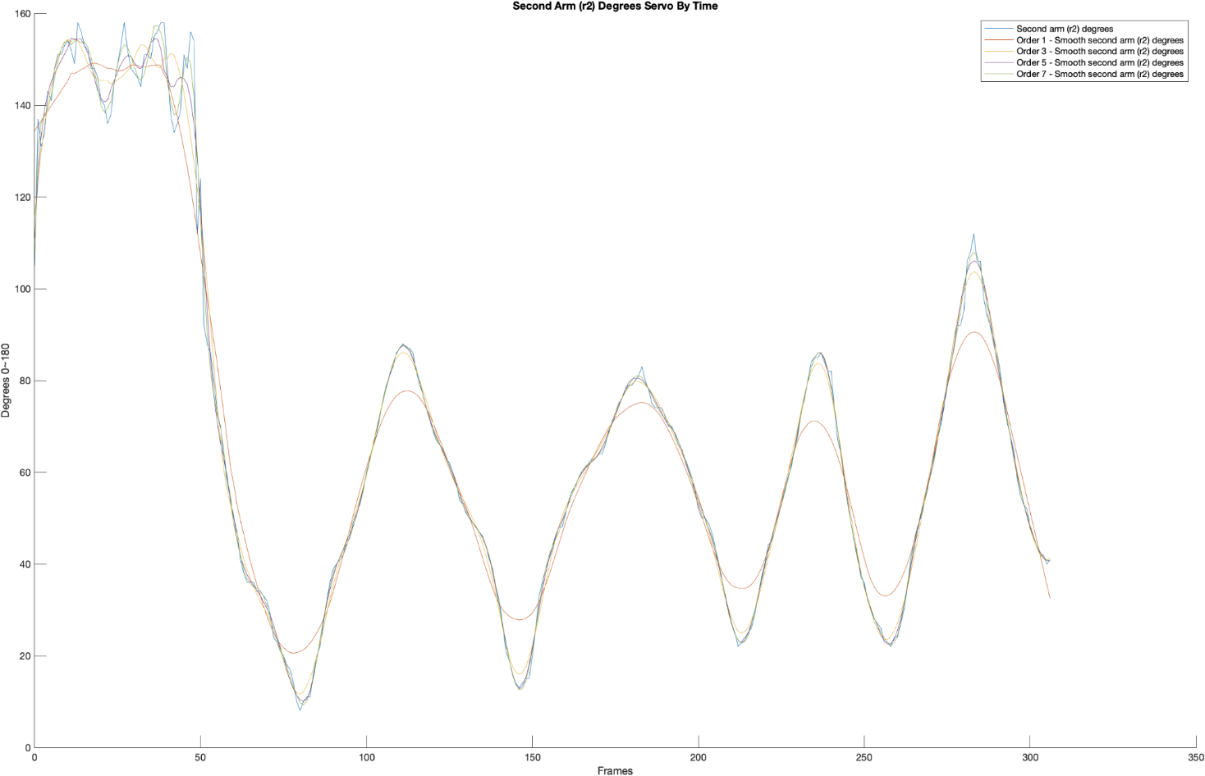During the simulation, we have analyzed serval orders 1, 3, 5 &7 results in the same framelen 21.

**Figure no. 15: Servomotor r2 operation with "Smooth" function, degrees vs. time frames.**

As shown in the graph presented above (figure no.15), the motion movements are more various at the beginning, frames 0-50, therefore, the signals have more noise.

Zooming in the movements (degrees values) in frames 0-50, see figure no.16, we can better examine the results of the different orders on the received movement.

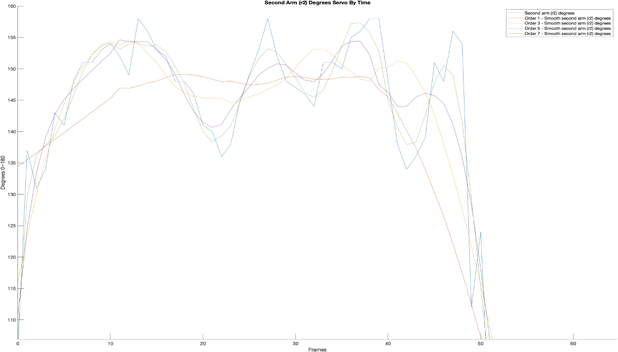

**Figure no. 16: Servomotor r2 operation with "Smooth" function, degrees vs. time frames (0-50)**

Visual estimation shows that the movements' flexibility is decreasing substantially in order no. 1 (the degrees values are similar along the motion and the graph in more flat in relation to the original).

The motion flexibility increases with the order increment, as a result we can see smoother and more distinguish movements in order no. 7 (see figures no. 17-18).

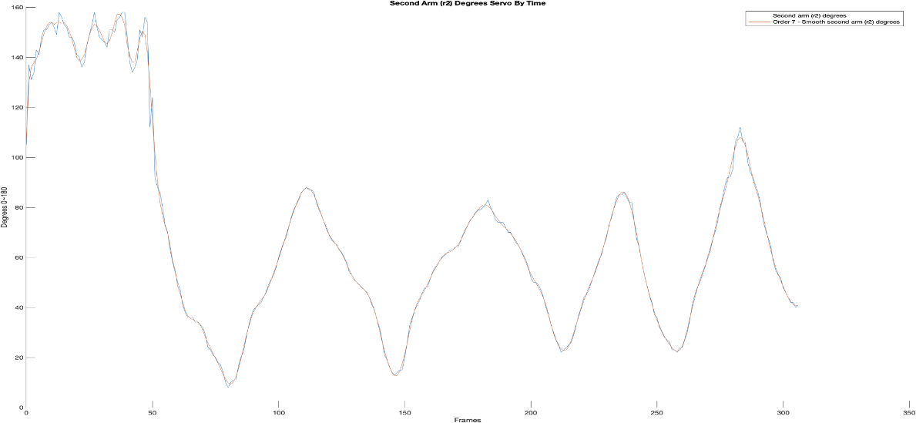

**Figure no. 17: Servomotor r2 operation, degrees vs. time frames, Original vs. "Smooth" function order 7**

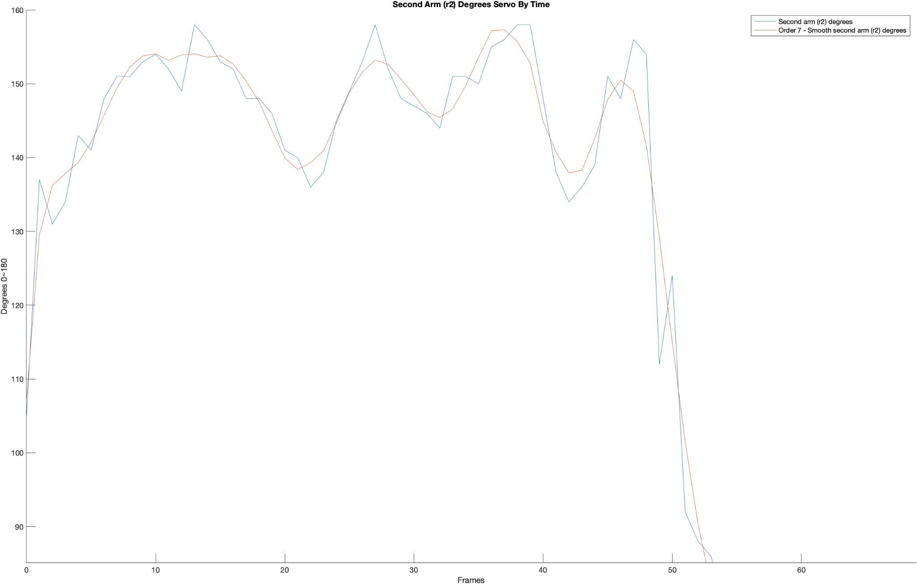

**Figure no. 18: Servomotor r2 operation, degrees vs. time frames (0-50), Original vs. "Smooth" function order 7**

In order to conclude if the alteration after implementing the "Smooth" Function is statistically significant we have performed a paired sample T-test. This procedure used to determine whether the mean difference between two sets of observations is significant. In a paired sample T-test, each subject or entity is measured twice, resulting in pairs of observations. In the following examination, the motion's degrees are measured in each time frame before and after the "Smooth function".

**Null Hypothesis:** H0: μd = 0 there is no significant difference between the means before and after the "Smooth function".

**Alternative Hypothesis:** H1: μd ≠ 0 there is a significant difference between the means before and after the "Smooth function".

**Point Estimate:** (the sample mean difference) is the point estimate of μd.

**Test statistic:**

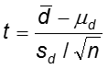

The statistical test was performed using JMP pro 13 software [19], figure no.19 presents the results.

The raw data are enclosed in appendix B.

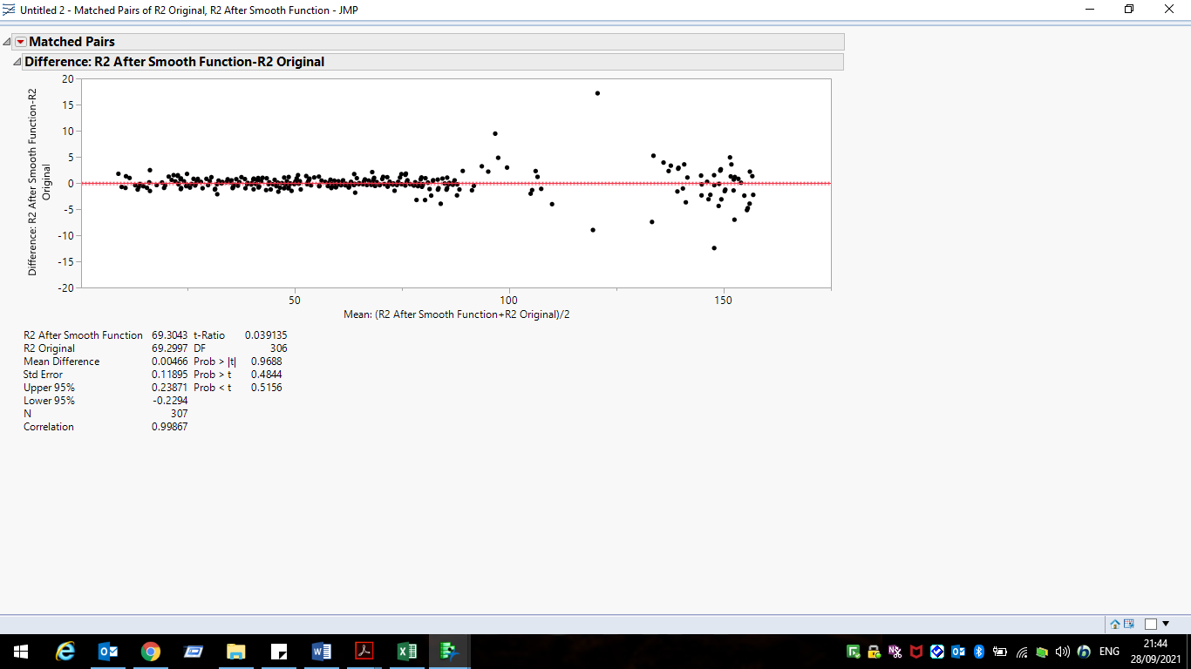

**Figure no. 19: Paired T- test Servomotor r2 operation before and after applying "Smooth" function (order 7).**

As we can conclude from the results, the alteration after applying the "Smooth" function (order 7) is not statistcly significant.

We have decided to examine the statistical significance of the alteration while performing faster and sharper movements on servomotor 3 (r3), the results are presented in the following graph (figure no. 20).

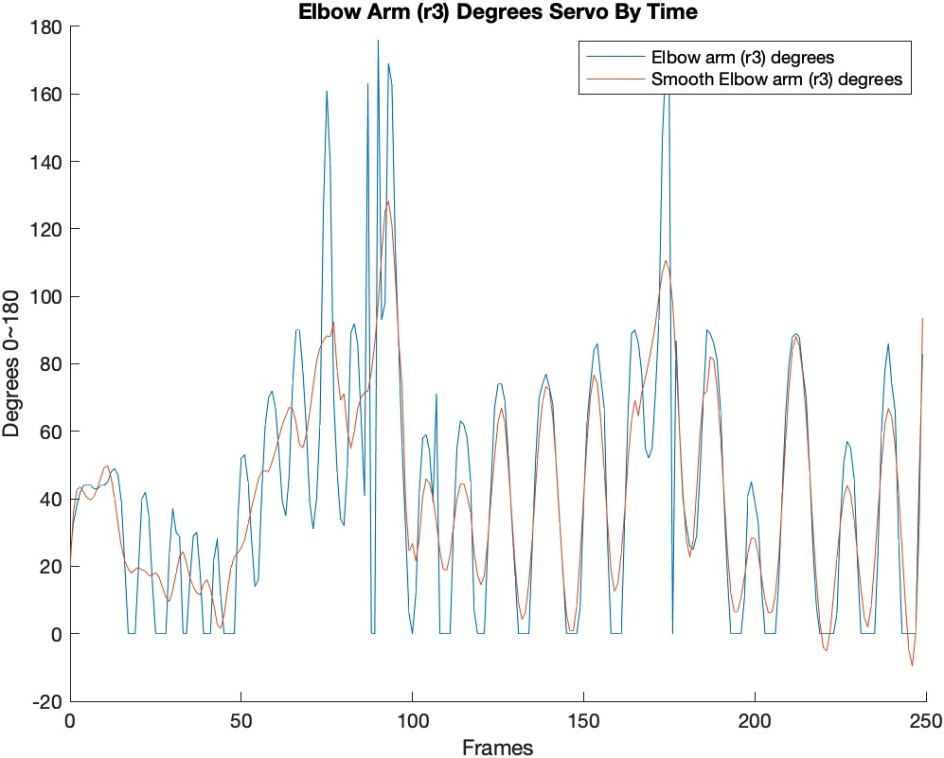**Figure no. 20: Servomotor r3 operation, degrees vs. time frames, Original vs. "Smooth" function order 5**

We have performed an additional T-test on the results received after performing faster and sharper movements, using JMP pro 13 software [19], figure no. 21 presents the results.

The raw data are enclosed in appendix B.

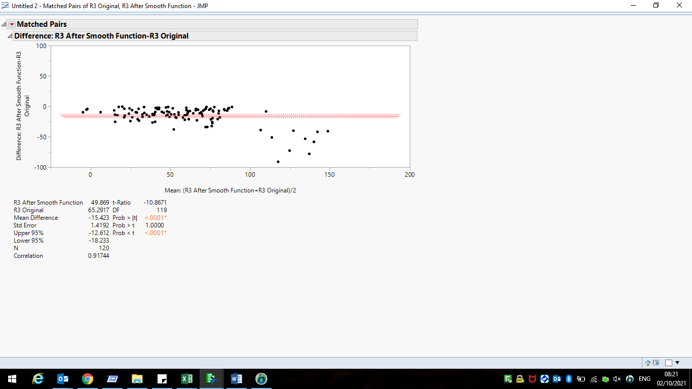

**Figure no. 21: Paired T- test Servomotor r3 operation before and after applying "Smooth" function (order 5).**

As we can conclude from the results, the alteration after applying the "Smooth" function (order 5) is **statistcly significant**, therefore we can improve our robotic arm operation while performing faster and sharper movements which the system mimics by applying the "Smooth" function.

**Appendix A: MediaPipe Pose**

MediaPipe Pose is a ML solution for high-fidelity body pose tracking, inferring 33 3D landmarks and background segmentation mask on the whole body from RGB video frames utilizing our BlazePose research that also powers the ML Kit Pose Detection API.

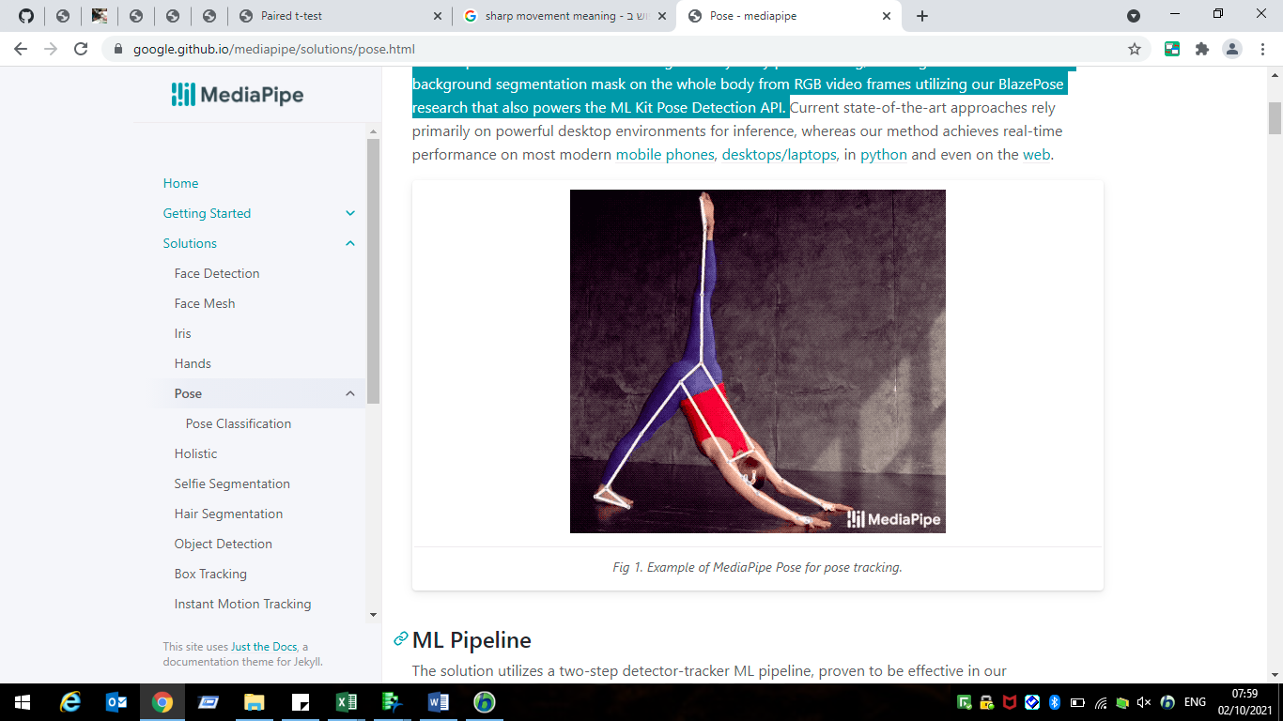

**Example of MediaPipe Pose for pose tracking**

**ML Pipeline**

The solution utilizes a two-step detector-tracker ML pipeline, proven to be effective in the MediaPipe Hands and MediaPipe Face Mesh solutions. Using a detector, the pipeline first locates the person/pose region-of-interest (ROI) within the frame. The tracker subsequently predicts the pose landmarks and segmentation mask within the ROI using the ROI-cropped frame as input.

The pipeline is implemented as a MediaPipe graph that uses a pose landmark subgraph from the pose landmark module and renders using a dedicated pose renderer subgraph. The pose landmark subgraph internally uses a pose detection subgraph from the pose detection module.

## Models

## Person/pose Detection Model (BlazePose Detector)

The detector is inspired by lightweight BlazeFace model, used in MediaPipe Face Detection, as a proxy for a person detector. It explicitly predicts two additional virtual key points that firmly describe the human body center, rotation and scale as a circle. Inspired by Leonardo’s Vitruvian man, the model predict the midpoint of a person’s hips, the radius of a circle circumscribing the whole person, and the incline angle of the line connecting the shoulder and hip midpoints.

| **pose_tracking_detector_vitruvian_man.png** |
| --- |
| **Vitruvian man aligned via two virtual key points predicted by BlazePose detector in addition to the face-bounding box.** |

### **Pose Landmark Model (BlazePose GHUM 3D)**

The landmark model in MediaPipe Pose predicts the location of 33 pose landmarks (see figure below).

| **pose_tracking_full_body_landmarks.png** |
| --- |
| **33 pose landmarks** |

Optionally, MediaPipe Pose can predicts a full-body segmentation mask represented as a two-class segmentation (human or background).

**Appendix B: Sensitivity Analysis Raw Data**

**First test: applying the "Smooth" function (order 7) on R2**

|  |  |  |  |  |  |
| --- | --- | --- | --- | --- | --- |
| **Frame** | **R2 Original** | **R2 After Smooth Function** | **Frame** | **R2 Original** | **R2 After Smooth Function** |
| 0 | 105 | 107.295213 | 21 | 140 | 138.3955938 |
| 1 | 137 | 129.5559772 | 22 | 136 | 139.3254902 |
| 2 | 131 | 136.2296253 | 23 | 138 | 140.9262111 |
| 3 | 134 | 137.8593052 | 24 | 145 | 144.745469 |
| 4 | 143 | 139.3194518 | 25 | 149 | 148.845288 |
| 5 | 141 | 142.0583818 | 26 | 153 | 151.5872362 |
| 6 | 148 | 145.7519986 | 27 | 158 | 153.2067603 |
| 7 | 151 | 149.4466943 | 28 | 152 | 152.6282317 |
| 8 | 151 | 152.2695341 | 29 | 148 | 150.6394101 |
| 9 | 153 | 153.7838088 | 30 | 147 | 148.5061396 |
| 10 | 154 | 154.0680427 | 31 | 146 | 146.2427484 |
| 11 | 152 | 153.154036 | 32 | 144 | 145.4289466 |
| 12 | 149 | 153.9126127 | 33 | 151 | 146.6220547 |
| 13 | 158 | 154.0644023 | 34 | 151 | 149.7375959 |
| 14 | 156 | 153.5953276 | 35 | 150 | 153.5697163 |
| 15 | 153 | 153.8055129 | 36 | 155 | 157.1866469 |
| 16 | 152 | 152.6749944 | 37 | 156 | 157.3189991 |
| 17 | 148 | 150.3809874 | 38 | 158 | 155.7442994 |
| 18 | 148 | 147.596557 | 39 | 158 | 152.8275976 |
| 19 | 146 | 143.6459969 | 40 | 148 | 144.8986285 |
| 20 | 141 | 139.9604164 | 41 | 138 | 140.7437639 |

|  |  |  |  |  |  |
| --- | --- | --- | --- | --- | --- |
| **Frame** | **R2 Original** | **R2 After Smooth Function** | **Frame** | **R2 Original** | **R2 After Smooth Function** |
| 42 | 134 | 137.9210571 | 64 | 36 | 36.73980946 |
| 43 | 136 | 138.300522 | 65 | 36 | 35.68919998 |
| 44 | 139 | 142.5708141 | 66 | 36 | 35.03185415 |
| 45 | 151 | 147.883361 | 67 | 34 | 34.72067423 |
| 46 | 148 | 150.4982935 | 68 | 34 | 34.18220487 |
| 47 | 156 | 148.9902424 | 69 | 33 | 32.9207879 |
| 48 | 154 | 141.5592677 | 70 | 32 | 30.76031767 |
| 49 | 112 | 129.1823514 | 71 | 29 | 28.01234501 |
| 50 | 124 | 115.0200326 | 72 | 24 | 25.75601322 |
| 51 | 92 | 101.460364 | 73 | 23 | 23.72899897 |
| 52 | 88 | 90.31897519 | 74 | 21 | 21.59976668 |
| 53 | 86 | 82.04258686 | 75 | 20 | 19.58087375 |
| 54 | 80 | 76.76307264 | 76 | 18 | 17.61271892 |
| 55 | 73 | 72.69688757 | 77 | 17 | 15.48799749 |
| 56 | 70 | 69.70147021 | 78 | 14 | 13.26935583 |
| 57 | 63 | 64.71717743 | 79 | 10 | 11.30224496 |
| 58 | 58 | 58.639108 | 80 | 8 | 9.776958167 |
| 59 | 54 | 54.99048773 | 81 | 10 | 9.267208088 |
| 60 | 50 | 48.50893047 | 82 | 11 | 10.07545505 |
| 61 | 47 | 45.34908242 | 83 | 11 | 11.975986 |
| 62 | 41 | 41.96488536 | 84 | 16 | 15.0901213 |
| 63 | 38 | 38.76513962 | 85 | 20 | 19.07527856 |

|  |  |  |  |  |  |
| --- | --- | --- | --- | --- | --- |
| **Frame** | **R2 Original** | **R2 After Smooth Function** | **Frame** | **R2 Original** | **R2 After Smooth Function** |
| 86 | 22 | 23.48788681 | 151 | 26 | 25.8287492 |
| 87 | 27 | 27.7933444 | 152 | 33 | 30.86267331 |
| 88 | 32 | 31.76380252 | 153 | 36 | 35.35258222 |
| 89 | 36 | 35.23735212 | 154 | 39 | 39.03769312 |
| 90 | 39 | 38.00501039 | 155 | 41 | 41.87646012 |
| 91 | 40 | 39.97007523 | 156 | 43 | 43.9163309 |
| 92 | 41 | 41.51152391 | 157 | 46 | 45.41465727 |
| 93 | 42 | 43.00091234 | 158 | 48 | 46.99604254 |
| 94 | 44 | 44.14817607 | 159 | 48 | 49.15728452 |
| 95 | 46 | 45.73898984 | 160 | 51 | 51.35773919 |
| 96 | 49 | 48.14662658 | 161 | 54 | 53.56759546 |
| 97 | 51 | 50.87243086 | 162 | 56 | 55.39381104 |
| 98 | 53 | 53.6830888 | 163 | 57 | 57.22038258 |
| 99 | 56 | 56.48158119 | 164 | 59 | 58.92492784 |
| 100 | 60 | 59.43460313 | 165 | 60 | 60.3412692 |
| 101 | 63 | 62.5227442 | 166 | 61 | 61.32215791 |
| 102 | 66 | 65.76558831 | 167 | 62 | 61.86803069 |
| 103 | 68 | 68.9942029 | 168 | 63 | 62.24207834 |
| 104 | 72 | 72.25314309 | 169 | 63 | 62.9781487 |
| 105 | 76 | 75.53585797 | 170 | 64 | 63.85622112 |
| 106 | 79 | 78.41483376 | 171 | 64 | 64.93148173 |
| 107 | 81 | 81.094339 | 172 | 66 | 66.46249981 |
| 108 | 83 | 83.6622994 | 173 | 69 | 68.44674175 |
| 109 | 86 | 85.73715918 | 174 | 71 | 70.80283873 |
| 110 | 87 | 87.14625267 | 175 | 73 | 72.93181077 |
| 111 | 88 | 87.74354856 | 176 | 75 | 74.77534288 |
| 112 | 87 | 87.52761101 | 177 | 76 | 76.22747491 |
| 113 | 87 | 86.67985522 | 178 | 78 | 77.52009991 |
| 114 | 86 | 85.01107671 | 179 | 79 | 78.85332556 |
| 115 | 82 | 82.53745532 | 180 | 79 | 80.07020535 |
| 116 | 79 | 79.70467986 | 181 | 80 | 80.93364144 |
| 117 | 77 | 76.79171714 | 182 | 81 | 81.04392396 |
| 118 | 74 | 74.04836003 | 183 | 83 | 80.59973677 |
| 119 | 72 | 71.3103932 | 184 | 80 | 79.61325735 |
| 120 | 69 | 69.18420006 | 185 | 78 | 78.15636619 |
| 121 | 67 | 67.47336115 | 186 | 75 | 76.57452925 |
| 122 | 66 | 66.17513049 | 187 | 74 | 75.06001705 |
| 123 | 65 | 64.80355065 | 188 | 74 | 73.63091189 |
| 124 | 63 | 63.23173749 | 189 | 74 | 72.53301327 |

|  |  |  |  |  |  |
| --- | --- | --- | --- | --- | --- |
| **Frame** | **R2 Original** | **R2 After Smooth Function** | **Frame** | **R2 Original** | **R2 After Smooth Function** |
| 125 | 62 | 61.5812357 | 190 | 72 | 71.73087151 |
| 126 | 60 | 59.66351087 | 191 | 70 | 70.78478635 |
| 127 | 58 | 57.42801035 | 192 | 70 | 69.59933893 |
| 128 | 54 | 55.0735496 | 193 | 68 | 68.1407188 |
| 129 | 53 | 52.93247484 | 194 | 66 | 66.70048608 |
| 130 | 51 | 51.17775385 | 195 | 65 | 64.94424552 |
| 131 | 50 | 49.92940578 | 196 | 63 | 62.97667699 |
| 132 | 49 | 48.92656107 | 197 | 61 | 60.59389181 |
| 133 | 48 | 47.85878464 | 198 | 59 | 58.05227861 |
| 134 | 47 | 46.99607245 | 199 | 56 | 55.49106654 |
| 135 | 46 | 45.79570153 | 200 | 52 | 53.34338703 |
| 136 | 44 | 44.07069891 | 201 | 50 | 51.51695906 |
| 137 | 41 | 41.6431552 | 202 | 50 | 49.79472637 |
| 138 | 39 | 38.77084399 | 203 | 49 | 47.99096633 |
| 139 | 35 | 35.15797849 | 204 | 47 | 46.11904997 |
| 140 | 32 | 30.88343878 | 205 | 44 | 43.78659009 |
| 141 | 27 | 26.53976758 | 206 | 40 | 40.8423685 |
| 142 | 21 | 22.50828435 | 207 | 37 | 37.17550141 |
| 143 | 19 | 19.12107806 | 208 | 33 | 33.21201896 |
| 144 | 16 | 16.13467941 | 209 | 30 | 29.59743946 |
| 145 | 14 | 13.82489942 | 210 | 27 | 26.80400832 |
| 146 | 13 | 12.59352986 | 211 | 25 | 24.69078536 |
| 147 | 14 | 12.75817891 | 212 | 22 | 23.37574371 |
| 148 | 15 | 14.39425375 | 213 | 23 | 22.76252524 |
| 149 | 15 | 17.46750423 | 214 | 24 | 23.03903621 |
| 150 | 20 | 21.23188406 | 215 | 25 | 24.41199204 |
|  |  |  |  |  |  |
| **Frame** | **R2 Original** | **R2 After Smooth Function** | **Frame** | **R2 Original** | **R2 After Smooth Function** |
| 216 | 26 | 26.80179776 | 246 | 49 | 48.82263502 |
| 217 | 29 | 29.80090337 | 247 | 45 | 44.76873813 |
| 218 | 33 | 33.21205785 | 248 | 42 | 41.38053275 |
| 219 | 37 | 36.49371981 | 249 | 37 | 38.13218169 |
| 220 | 40 | 39.72137719 | 250 | 36 | 35.00442111 |
| 221 | 44 | 42.65293669 | 251 | 32 | 32.47576614 |
| 222 | 45 | 45.61684091 | 252 | 30 | 30.37497196 |
| 223 | 47 | 48.053858 | 253 | 28 | 28.23164476 |
| 224 | 50 | 50.31470364 | 254 | 27 | 26.51036628 |
| 225 | 53 | 52.78233649 | 255 | 26 | 25.14086837 |
| 226 | 56 | 55.4737919 | 256 | 23 | 23.90017499 |
| 227 | 59 | 58.29058195 | 257 | 23 | 22.89760548 |
| 228 | 61 | 61.52718027 | 258 | 22 | 22.31916065 |
| 229 | 65 | 64.9951631 | 259 | 24 | 22.85040008 |
| 230 | 68 | 68.65405244 | 260 | 24 | 24.34033293 |
| 231 | 73 | 72.70374658 | 261 | 27 | 27.30653445 |
| 232 | 76 | 76.5331718 | 262 | 30 | 31.12352792 |
| 233 | 80 | 79.78113998 | 263 | 35 | 35.51230762 |
| 234 | 84 | 82.74485575 | 264 | 41 | 39.81079553 |
| 235 | 85 | 84.91770988 | 265 | 45 | 43.78172328 |
| 236 | 85 | 86.04010709 | 266 | 48 | 47.6699481 |
| 237 | 86 | 86.03473475 | 267 | 50 | 50.8943749 |
| 238 | 84 | 84.86008884 | 268 | 53 | 53.84866215 |
| 239 | 82 | 82.44775579 | 269 | 56 | 56.48489553 |
| 240 | 82 | 78.75031184 | 270 | 60 | 59.17988663 |
| 241 | 74 | 74.23664618 | 271 | 63 | 62.15773022 |
| 242 | 67 | 69.10310046 | 272 | 67 | 66.63461211 |
| 243 | 64 | 63.61380177 | 273 | 70 | 71.19098428 |
| 244 | 58 | 58.08186237 | 274 | 74 | 75.71561897 |
| 245 | 53 | 53.11075216 | 275 | 80 | 79.29371382 |
|  |  |  |  |  |  |
| **Frame** | **R2 Original** | **R2 After Smooth Function** |  |  |  |
| 276 | 84 | 83.02187822 |  |  |  |
| 277 | 89 | 86.64031648 |  |  |  |
| 278 | 92 | 90.61379279 |  |  |  |
| 279 | 92 | 95.21227921 |  |  |  |
| 280 | 95 | 99.8396554 |  |  |  |
| 281 | 106 | 103.9738801 |  |  |  |
| 282 | 108 | 106.8907076 |  |  |  |
| 283 | 112 | 107.9641525 |  |  |  |
| 284 | 106 | 107.1895066 |  |  |  |
| 285 | 106 | 104.6566848 |  |  |  |
| 286 | 98 | 100.9666861 |  |  |  |
| 287 | 94 | 96.1912176 |  |  |  |
| 288 | 92 | 91.46805163 |  |  |  |
| 289 | 89 | 87.77106834 |  |  |  |
| 290 | 86 | 84.7354033 |  |  |  |
| 291 | 82 | 80.85391783 |  |  |  |
| 292 | 75 | 76.81912026 |  |  |  |
| 293 | 71 | 72.11431178 |  |  |  |
| 294 | 68 | 67.66598465 |  |  |  |
| 295 | 65 | 63.15954293 |  |  |  |
| 296 | 59 | 59.45573055 |  |  |  |
| 297 | 55 | 56.23308595 |  |  |  |
| 298 | 53 | 53.37810073 |  |  |  |
| 299 | 52 | 50.78100385 |  |  |  |
| 300 | 48 | 48.35629789 |  |  |  |
| 301 | 46 | 46.08175595 |  |  |  |
| 302 | 44 | 44.02040693 |  |  |  |
| 303 | 42 | 42.31609974 |  |  |  |
| 304 | 42 | 41.15323632 |  |  |  |
| 305 | 40 | 40.67126419 |  |  |  |
| 306 | 41 | 40.82451848 |  |  |  |

**Second test: applying the "Smooth" function (order 5) on R3 (sharper movements)**

|  |  |  |
| --- | --- | --- |
| **Frame** | **R3 Original** | **R3 After Smooth Function** |
| 0 | 23 | 19.21868566 |
| 4 | 44 | 41.8935868 |
| 5 | 44 | 40.21340504 |
| 6 | 44 | 39.68852847 |
| 7 | 43 | 40.75113819 |
| 12 | 48 | 46.28553353 |
| 13 | 49 | 40.19805396 |
| 14 | 47 | 32.62509086 |
| 15 | 39 | 25.82645617 |
| 20 | 20 | 19.66225025 |
| 21 | 40 | 18.94465704 |
| 22 | 42 | 18.59055055 |
| 23 | 35 | 17.15528719 |
| 29 | 24 | 9.539757322 |
| 30 | 37 | 12.90325174 |
| 31 | 30 | 18.02294868 |
| 32 | 29 | 22.94534546 |
| 36 | 29 | 13.91407034 |
| 37 | 30 | 12.04687422 |
| 38 | 18 | 11.5624214 |
| 42 | 22 | 8.562536777 |
| 43 | 28 | 2.743714786 |
| 44 | 11 | 1.522554468 |
| 49 | 34 | 23.99449263 |
| 50 | 52 | 25.53587293 |
| 51 | 53 | 27.82572928 |
| 52 | 45 | 32.4574313 |
| 57 | 62 | 48.23428648 |
| 58 | 70 | 48.08519893 |
| 59 | 72 | 50.96872873 |
| 60 | 67 | 54.30217103 |
| 65 | 74 | 66.66546545 |
| 66 | 90 | 62.55776782 |
| 67 | 90 | 56.19311578 |
| 68 | 78 | 55.1870046 |
| 69 | 61 | 58.93854201 |
| 74 | 126 | 87.07825318 |
| 75 | 161 | 88.30332865 |
| 76 | 139 | 88.02278715 |
| 82 | 89 | 55.08462973 |
| 83 | 92 | 59.72564275 |
| 84 | 86 | 66.58830067 |
| 87 | 163 | 71.96911717 |
| **Frame** | **R3 Original** | **R3 After Smooth Function** |
| 90 | 176 | 98.00768417 |
| 93 | 169 | 128.2535238 |
| 94 | 163 | 121.2284945 |
| 95 | 114 | 105.8181413 |
| 102 | 42 | 28.3246005 |
| 103 | 58 | 40.69334077 |
| 104 | 59 | 45.95689864 |
| 105 | 54 | 44.49558679 |
| 107 | 71 | 33.19811165 |
| 113 | 55 | 39.82654847 |
| 114 | 63 | 44.37723593 |
| 115 | 62 | 44.47916466 |
| 116 | 58 | 40.84978944 |
| 117 | 45 | 35.99740784 |
| 123 | 45 | 40.6536546 |
| 124 | 67 | 52.69869815 |
| 125 | 74 | 62.66910371 |
| 126 | 74 | 66.89668673 |
| 127 | 69 | 62.65384689 |
| 128 | 53 | 49.92705036 |
| 136 | 52 | 43.89485991 |
| 137 | 70 | 58.59539642 |
| 138 | 74 | 68.75789858 |
| 139 | 77 | 73.26245024 |
| 140 | 73 | 72.18889295 |
| 141 | 68 | 63.99897698 |
| 144 | 18 | 17.21507221 |
| 151 | 63 | 57.02791762 |
| 152 | 74 | 70.3147703 |
| 153 | 84 | 76.73599215 |
| 154 | 86 | 74.39898852 |
| 155 | 76 | 63.47774167 |
| 156 | 67 | 48.68499125 |
| 163 | 66 | 51.70398246 |
| 164 | 89 | 63.36472127 |
| 165 | 90 | 69.19860777 |
| 166 | 86 | 64.63188662 |
| 167 | 77 | 71.51531258 |
| 173 | 147 | 107.1412265 |
| 174 | 169 | 110.7646059 |
| 175 | 161 | 107.8318905 |
| 177 | 87 | 80.95905236 |
| 180 | 32 | 28.14163414 |
| 181 | 26 | 22.80171913 |
| **Frame** | **R3 Original** | **R3 After Smooth Function** |
| 186 | 90 | 71.9730131 |
| 187 | 89 | 82.05312001 |
| 188 | 86 | 81.28624502 |
| 189 | 81 | 72.66812299 |
| 190 | 66 | 58.42622926 |
| 198 | 41 | 23.99870007 |
| 199 | 45 | 28.49925197 |
| 200 | 39 | 28.32059689 |
| 201 | 33 | 23.55322962 |
| 208 | 42 | 39.47794166 |
| 209 | 65 | 57.17139011 |
| 210 | 80 | 73.13430764 |
| 211 | 88 | 84.32075073 |
| 212 | 89 | 88.12977713 |
| 213 | 88 | 85.30240178 |
| 214 | 78 | 77.01371844 |
| 215 | 70 | 64.57901275 |
| 216 | 49 | 48.16981328 |
| 220 | 0 | -4.102551776 |
| 221 | 0 | -5.186396939 |
| 225 | 34 | 32.94277253 |
| 226 | 51 | 40.67365344 |
| 227 | 57 | 44.00523431 |
| 228 | 55 | 41.34268408 |
| 229 | 46 | 33.94586466 |
| 237 | 60 | 50.1310309 |
| 238 | 78 | 62.18924677 |
| 239 | 86 | 66.79199277 |
| 240 | 74 | 64.21129061 |
| 241 | 66 | 55.61533373 |
| 245 | 0 | -4.833212178 |
| 246 | 0 | -9.571579679 |
| 248 | 46 | 31.90223255 |

1. **Refrences**

[1] S. Y. Nof, Handbook of Industrial Robotics, 2nd ed. John Wiley &

Sons, 1999.

[2] J. Hammel, K. Hall, D. Lees, L. Leifer, M. V. der Loos, I. Perkash, and R. Crigler, “Clinical evaluation of a desktop robotic assistant,” J.Rehabil. Res. Dev., 1989, vol. 26, pp. 1–16

[3] M. Hans, B. Graf, and R. Schraft, “Robotic home assistant care-o-bot: past-present-future,” in Proc. of 11th IEEE Int. Workshop on Robot and Human Interactive Communication, 2002, pp. 380 – 385.

[4] R. B. Rusu, A. Holzbach, R. Diankov, G. Bradski and M. Beetz, "Perception for mobile manipulation and grasping using active stereo," 2009 9th IEEE-RAS International Conference on Humanoid Robots, 2009, pp. 632-638

[5] Paik, J.K., et al. Development of an Anthropomorphic Robotic Arm and Hand for Interactive Humanoids. Journal of Bionic Engineering, 2012; 9(2): 133-142.

[6] Islam, M., M. Wazed and T. Mohammad. Design and fabrication of a 5 DOF dexterous robotic arm for Industrial tasks, 2007; pp: 58.

[7] Hirzinger, G. and A. Albu-Schaeffer. Lightweight robots. Scholarpedia, 2008; 3(4): 3889.

[8] Almurib, H.A., H.F. Al-Qrimli and N. Kumar. A review of application industrial robotic design. In ICT and Knowledge Engineering (ICT & Knowledge Engineering), 2011 9th International Conference on IEEE; 2012.

[9] J. Younkoo, L. Dongjoon, K. Kyunghwan, and P. Jongoh, "A wearable robotic arm with high force-reflection capability," in 9th IEEE International Workshop on Robot and Human Interactive Communication, 2000, pp. 411-416.

[10] R. R. Smith and T. D. Lewis, "Metal plating of ABS and other plastics," Production Engineer, 1967, vol. 46, pp. 526-534.

[11] Corke P. Robotics, Vision and Control Fundamental Algorithms in MATLAB. (Siciliano B, Khatib O, Groen F, Eds.) Berlin: Springer-Verlag 2011.

[12] Jha DK. Dynamics of Rigid Bodies. In D. K. Jha, Text Book Of Rotational Mechanics. Delhi: Discovery Publishing Pvt. Ltd., 2006; pp. 12-17.

[13] Benenson, W., Harris, J.W., Stöcker, H., Lutz, H. Handbook of Physics. New York: Springer Publishing, 2006.

[14] Moreira R., et al. Can human posture and range of motion be measured automatically by smart mobile applications?, Medical Hypotheses, Vol. 142, 2020.

[15] Keskin, Cem & Kıraç, Furkan & Kara, Yunus & Akarun, Lale. Real Time Hand Pose Estimation Using Depth Sensors. Proceedings of the IEEE International Conference on Computer Vision. (2011), pages 1228-1234.

[16] Liuhao Ge, Zhou Ren, Yuncheng Li, Zehao Xue, Yingying

Wang, Jianfei Cai, and Junsong Yuan. 3D hand shape and pose estimation from a single rgb image. In Proceedings of the IEEE conference on computer vision and pattern recognition, 2019, pages 10833–10842.

[17] Savitzky, M.J.E. Golay, Smoothing anddifferentiation of data by simplified least-squares procedures, Anal. Chem. 36 (8) (1964) 1627–1639.

[18] S.J. Orfanidis, Introduction to Signal Processing, PrenticeHall, EnglewoodCliffs, NJ, 1996 (Chapter 8).

[19] JMP®, Version 13. SAS Institute Inc., Cary, NC, 1989–2021.